

**Year 2**

**Computer Rules**

****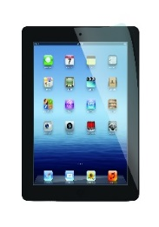

**Using the Internet Safely - Key Stage 1**

* I will look after all school computer equipment and use it properly.
* I will tell an adult if I see anything on a computer which worries or upsets me.
* I will only take a photograph or video of someone if they say it is alright.
* I will tell an adult if messages or boxes pop up on the screen.
* All messages I send on a computer will be kind.
* I will not open other people’s computer files without permission.
* I will not share my personal information or talk to people I do not know when using the internet.
* I understand that if I do not follow these

rules, I may not be allowed to use the

school computers or internet.

Think Before You Click!

Name.....................................................................................................