

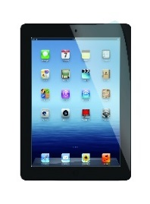****

**Year 5**

**Computer Rules**

**Using the Internet Safely - Key Stage 2**

* I will look after all school IT equipment and use it properly.
* I will ask for permission before using the internet.
* I will keep any passwords secret and not share them with others.
* All of the messages I send on a computer will be polite.
* I will not open other people’s files without permission.
* I will tell an adult if I see anything which upsets me.
* I will ask permission before I open files or links which ‘pop up’.
* I understand that I must not give out any personal details, such as my name, address or phone number or arrange to meet anyone.
* I will only take a photograph or video of someone if they say it is alright.
* I will not bring mobile phones into school, without the permission of my teacher.
* I will not bring in disks, CD’s or data storage devices from outside school and try to use them on the school computers without prior permission.
* I know that teachers can check my computer files and the internet sites I visit and that if they have any concerns about my safety they will contact my parent/carer.
* I understand that if I deliberately break these rules, I could be stopped from using the internet or computers.

Think Before You Click!

Pupil name..................................................................................

Signed...........................................................................................